**EGERTONUNIVERSITY**

**FACULTY OF SCIENCE**

**DEPARTMENT OF COMPUTER SCIENCE**

**SYSTEM REQUIREMENTS SPECIFICATIONS FOR**

**AN ONLINE AGRIBUSINESS SYSTEM**

**NAME: TOBIAS MUTUKU MUNYIVA**

**REG NO: S13/03125/18**

**SUPERVISOR: MR. INNOCENT NYALALA**

TABLE OF CONTENT

1.1 INTRODUCTION 3

CHAPTER 2 4

2.1 OVERALL DESCRIPTION 4

2.2 PRODUCT PERSPECTIVE 4

2.3 PRODUCT FEATURES 6

2.4 USER PROBLEM STATEMENT 7

2.5 USER OBJECTIVES 7

2.6 ASSUMPTIONS 8

2.7 DEPENDENCIES 8

CHAPTER 3 9

3.1 SYSTEM FEATURES 9

3.1.1 USER REGISTRATION AND AUTHENTICTAION 9

CHAPTER 4 10

4.1 EXTERNAL INTERFACE REQUIRENTS 10

4.2 FUNCTIONAL REQUIREMENTS 10

4.2.1 INPUT SPECIFICATIONS 10

4.3.1 PROCESSING SPECIFICATIONS 10

4.3.2 OUTPUT SPECIFICATIONS 11

4.3.3 SOFTWARE SPECIFICATIONS 11

4.3.4 HARDWARE SPECIFICATIONS 11

4.3.5 USER REQUIREMENTS 11

4.3.6 SYTEM REQUIREMENTS 11

4.3 NON-FUNCTIONAL REQUIREMENTS 13

4.3.1 PRODUCT REQUIREMENTS 13

4.3.2 ORGANIZATON REQUIREMENTS 13

4.4 OBJECT-ORIENTED DOMAIN ANALYSIS 13

# CHAPTER 1

## INTRODUCTION

The System Requirements Specifications (SRS) for an online agribusiness system describes the design decisions, architectural designs and the detailed design to implement a functional and well working ecommerce system. The SRS document is an essential part of the software development process, as its serves as a blueprint for the system design, development and testing phases.

The SRS document simplifies the complexities in the implementations of the ecommerce system so that the customers and the administrators can easily understand the functionalities and capabilities of the system. Furthermore, this SRS gives a detailed explanation of the high-level structure of the ecommerce system in terms of functions, performance, external interfaces and design.

The SRS for an online agribusiness system is a crucial document that ensure the success development and deployment of a fully functioning and efficient ecommerce system that meets the customers’ and service provides’ needs, expectations and requirements.

# CHAPTER 2

## 2.1 OVERALL DESCRIPTION

This section describes the general interpretation of the online agribusiness system in terms of the product perspective, product features, user problem statement, user objectives, operating environment, design and implementation constraints, user documentation, assumptions and dependencies and user constraints.

## 2.2 PRODUCT PERSPECTIVE

***“UptownFresh”*** is an advancement of the current system used in purchasing farm products from the physical open-air market where record keeping is done mostly by paper work and farmers who are the sellers and customers who are the buyers present themselves to the open-air market physically to sell and buy farm products. It’s of much importance to produce such a system since it will increase the productivity of each person involved in the selling and buying processes since time wastage will be reduced since physical movement will be eliminated and also money management since there will be elimination of the middle men who are the brokers who exploit both farmers and the customers. This system is therefore steered by the goodwill to help more farmers and customers country wide more so those in the town to locate fresh and high-quality farm produce easily. ***“UptowmFresh”*** is a web-based application system that consists of three parts: the client/customer side application which runs on the web browsers and back-office part which is used by the system administrator to manage the system, view details of customers, their orders, products available for uploads, verify customer payments, activate customers and authorize shipping of purchased goods.

***“UptownFresh”*** requires access to the internet to be able to register, log in and place an order and also check the order progress and shipping. This system also needs somewhere to store the data, that is the database. The data stored I the database includes the customers details, system administrators’ details, products details, order details and other system information.

The database used in this system is the SQL database mainly because it allows flexibility of access for the users. Figure 1, 2 and 3 shows the specified version of the two major parts that make up the ***“UptownFresh”*** application system: the web application and the database which are connected together using internet.

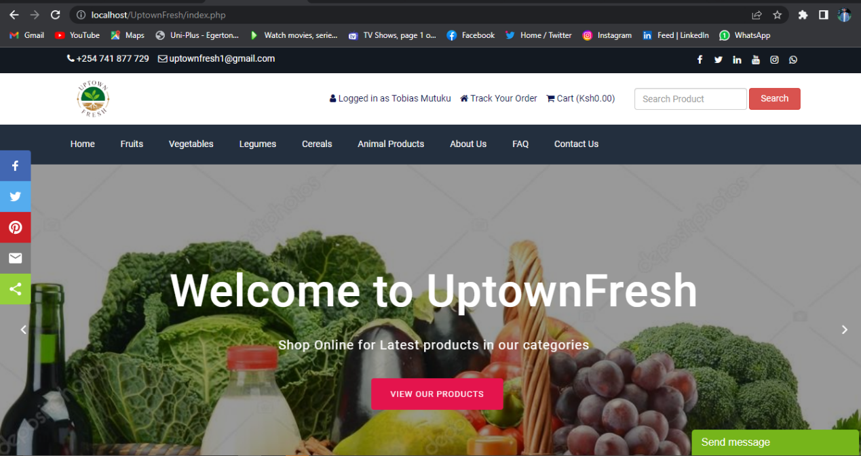

***Figure 1: The user interface for customers uses***

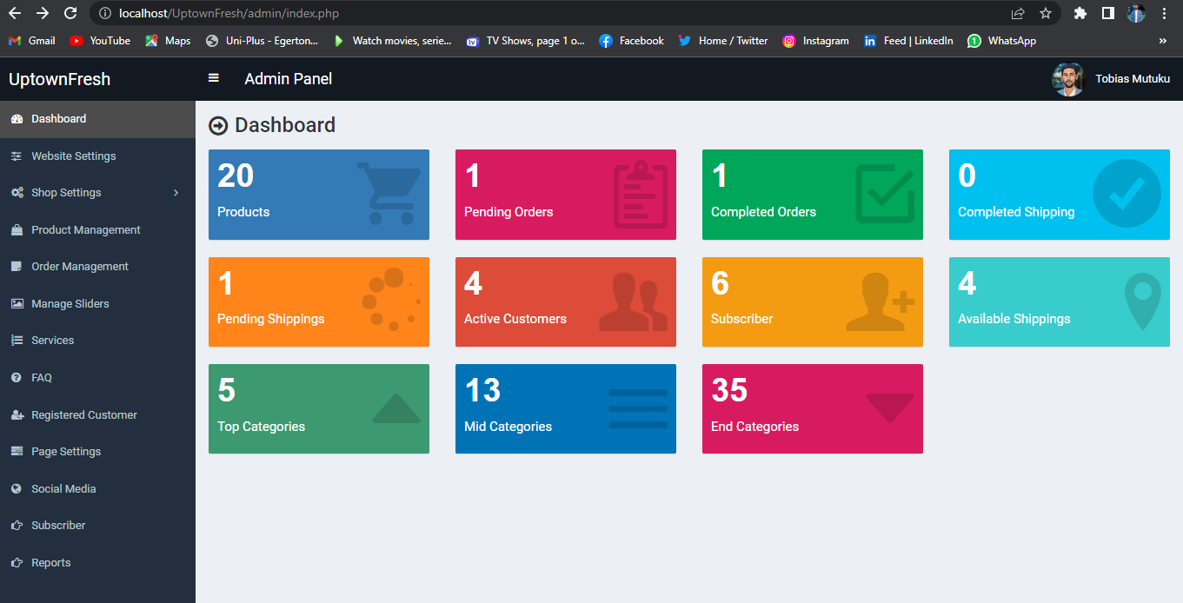

***Figure 2: Administrators’ panel for official use only.***

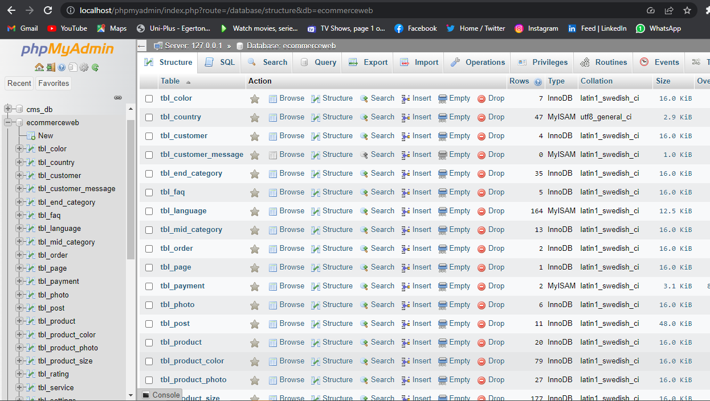

***Figure 3: MySQL database connected to the web application***

## 2.3 PRODUCT FEATURES

Product features is a description of the characteristics, appearance, components and functionalities of the system. The following list shows a brief outline of the major functionalities and features of this online agribusiness system.

1. User registration and authentication.

* Registration page for one to register and create account where the user clicks the “register” button and submits the details where the administrator confirms and activates the users account so that the user can be able to log in.
* The log in page accessed through the “log in” button whereby after the users account has been activated, he/she can be able to log in successfully.

1. View products catalogue and placing an order.

* After the customer has logged into the account, he /she can be able to view the available products and add them to the cart and check out.
* When the customer shops the needed products, they are able to place and order by proceeding to check out where they make payments and places an order successfully.

1. Update profile and shipping details.

* Customers are able to update their accounts profile and change passwords in case of any need to.
* They are also able to change and update their billing and shipping details in case they change their recent location.

1. View orders and print receipt.

* Customers after making payment, they are able to view their order and confirm if the system administrator has confirmed their payment successfully.
* They can also download print their purchase receipts after the payment has been confirmed.

1. Update products and system information.

* The system administrator is able to manage the whole system by uploading goods, activating and deactivating customers’ accounts, validating and verifying customers purchases and authorizes shipping.

## 2.4 USER PROBLEM STATEMENT

In modern days, there has been an increase in demand for fresh and high-quality agricultural products by the consumers, however the traditional way of shipping products from the farms by the farmers have had several challenges that has led to customer dissatisfaction including long wait time for products to reach the physical open-air market, invasions by the middle men, unclear pricing models, complexity in transporting the goods from the market to the desired destinations, spoiling of goods in the stores due to poor storage facilities and high production with consequently low demand. To address these challenges, there is a need to come up with a digital way to provide a seamless and efficient application system to smooth user experience.

## 2.5 USER OBJECTIVES

The primary objective of the online agribusiness system is to provide a user-friendly platform by enhancing customer experience. A system that enables customers to purchase and order goods quickly and easily at the comfort of their home or work place. The system should also have the following specific objectives: -

1. To provide streamlined services to the customers in shortest time possible: The system should automate the purchasing process, eliminate brokers, fast and efficient shipping of goods and reduce wait time.
2. Provide transparent pricing whereby the system displays prices of products for every user to see clearly.
3. Ensure availability of products which are in demand and should be accessed in real time and customers purchase and make orders instantly.

## 2.6 ASSUMPTIONS

While developing the system requirements specifications for this ecommerce system, the following assumptions were made: -

1. The application system is designed for all mobile handsets that has browsers with access to internet connection, desktops and portable laptops that enough memory capacity and reliable processor.
2. The system will be developed using the most modern versions of software development methodologies.
3. The system will be developed using the state-of-the-art technologies to ensure optimum performance, scalability and security.
4. The system will have a database that will store customers details, order details, products and other system information.

## 2.7 DEPENDENCIES

The following dependencies should be considered while in the process of developing this ecommerce system: -

1. The system development will depend on the availability of skilled software developer and project managers.
2. The systems success will depend on the cooperation and support of stakeholders including farmers, customers and internet service providers.
3. The system development will depend on the availability of relevant development tools and technologies.
4. The system will also require specified hardware for deployment and functionality.

# CHAPTER 3

## 3.1 SYSTEM FEATURES

### 3.1.1 USER REGISTRATION AND AUTHENTICTAION

Once the users access the application, they can view different categories of products but cannot make an order without creating an account through the “register” button. After the administrator has activated their account, the customer can now log in the system successfully and make his/her orders. When the user wants to log in their prompted to enter their email address and the password, they set during account creation.

The credentials are sent to the database for verification and validation. Once they have been ascertained to be correct the system logs in the user and taken to the dashboard which has different action buttons like customer update profile, update billing and shipping information, view orders, print receipt and track order progress.

# CHAPTER 4

## 4.1 EXTERNAL INTERFACE REQUIRENTS

1. The system should be designed to handle a large number of users at ago. It should be optimized for speed and efficiency to ensure a seamless user experience.
2. The system should be supported by all browser.
3. The system should comply with accessibility standards such as web content accessibility guidelines to ensure that all users can access all the systems functionalities without failure.
4. The system should also be compatible with most operating systems.
5. The system should comply with legal requirements including customer data protection regulations, privacy and consumer protection laws.
6. The system should also be able to run on various hardware configuration devices like desktops, laptops and smartphones.

## 4.2 FUNCTIONAL REQUIREMENTS

### 4.2.1 INPUT SPECIFICATIONS

1. First time customer must provide their details for registration and account creation.
2. Customers must use the set credentials to log into the system that is the email address and password.
3. Customers can enter their billing and shipping information and update them when need be.
4. Users can also update their profile and change passwords when need be.
5. Users can send messages to administrators by using the contact form.
6. Customers can order and purchase goods through the virtual cart and make payments.
7. The users can send email to the admin through the companies email address or call, SMS them directly through the companies contact number.
8. The user can also subscribe to company’s newsletter.

### 4.3.1 PROCESSING SPECIFICATIONS

1. The system can process the number of registered customers and subscribers.
2. The system can enable the admin to review customer orders, payments and can confirm or cancel them.
3. Can also removes subscribers and inactivate customers’ accounts.

### 4.3.2 OUTPUT SPECIFICATIONS

1. Display customers’ profile.
2. Display customers billing and shipping information.
3. Display a list of all the customers’ orders.
4. Display products available in the store/warehouse for purchase and shipping.
5. Display the number of all registered customers and subscribers.
6. Display the messages sent by the customers.
7. Display the list of all the products available.
8. Display all shipping available.

### 4.3.3 SOFTWARE SPECIFICATIONS

1. The application system can be supported and run at any known operating systems.
2. Th application system can also be used in available web browsers like google chrome, Mozilla etc.

### 4.3.4 HARDWARE SPECIFICATIONS

1. A computer with 2GB RAM memory and a minimum of 300Mhz processing speed.
2. A hard drive of 5GB of storage memory.

### 4.3.5 USER REQUIREMENTS

The application system will provide online purchase of agricultural products, make payments and follow ups on if the payment was verified and shipping of the goods to the desired location.

### 4.3.6 SYTEM REQUIREMENTS

Customers must have been registered by creating an account and the system administrator has activated the account. The admin will verify the details which identifies the customer before activating the account. Once the account is active, the customer can now be able to make orders and make payments online.

The system users should be privileged with the following functionalities: -

1. They should be able to manage their accounts i.e., update profile, change password, update billing and shopping details.
2. Can be able to log in the platform.

The system should provide the following functionalities to user: -

1. Allow full navigation of the system.
2. View and edit profile.
3. View the agricultural products available.
4. Register to the portal.
5. Subscribe to the system information.
6. Add products to the virtual cart.
7. View the products added to the cart and total amount.
8. Checkout from the cart to make payment and place an order.
9. View the list of the orders made.
10. Send messages to the admin through the email.
11. Contact the admin through the contact message form.
12. Print receipts after making an order.

The system should provide the following functionalities to the admin: -

1. Access the admin dashboard.
2. Add and change the products information.
3. View, activate and deactivate customers’ accounts.
4. Delete subscribers.
5. View the number of the registered customers and subscribers.
6. View the list of available products.
7. View customer orders.
8. Update customers payment information.
9. Authorize customers’ orders for shipping.
10. View and print reports.

Other requirements include the following.

1. The system should be able to display user profile details that can be edited.
2. The system should capture the users’ credentials.
3. It should have advanced monitoring and accountability of information.
4. It should be able to give customers notification after making actions.

## NON-FUNCTIONAL REQUIREMENTS

### PRODUCT REQUIREMENTS

1. The system should be available and fully operational throughout.
2. Accessibility clearance of the system information may only be granted to the system administrator.
3. During password entry the credentials should not be visible by hashing them.
4. The system should provide user-friendly interface for easier navigation.
5. Response to view information shall not take longer than 5 seconds to display.
6. System response to user’s request shall not take less than 4 seconds.
7. Constant daily refreshment of the information system despite the absence of updates.
8. Update failure must be able to be rolled back to default.

### ORGANIZATON REQUIREMENTS

1. The system database that will be used is MySQL.
2. The backend application will be created using PhP.

## OBJECT-ORIENTED DOMAIN ANALYSIS

1. Farm products, this is the primary object in the ecommerce system. its attributes include product name, product size, product color, product price. The behaviors associated with the product include confirming or cancelling customers’ orders.
2. Customers, this object represents the person who makes the purchase. Its attribute include name, company name, county, street, zip code, address, phone number, email address. The behaviors involved with customer include adding products in the cart, checkout, make payment, update personal information and updating billing and shipping information.
3. Purchasing products, this object represents customers request to purchase a product and make payment. Its attributes include adding interested products to the virtual cart, view the products in the cart, check the total summed up cost, check the shipping cost, proceed to checkout, make payment, check order details, print receipts, track order. The behaviors involved include cancelling orders, cancelling payments and logging out of the system.